User manual for VP44 CAN box tester

Tester use CAN BUS protocol for Driving VP pump

Connecting tester to pump

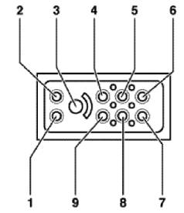
Three - wire cable

- brown
- blue
8. jelow/green

Two wire cable

6. brown
5. blue
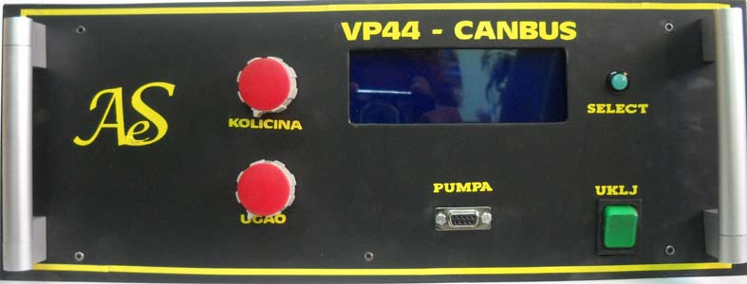

When tester is power up select pump with buton ANGLE (ugao)
All pump selected in 5 group
- opel old (stara): 002, 003, 004. 009, 011
- opel new: (nova) 015
- MAN: man, audi to 033, bmw, rover
- FORD: Ford only work virgin (tester make virgin VP29 not test)
- Audi 033: audi higest of 033
After selected push button set
Now imput fuel quantity 0 – 3000 (for example start injection is 2400, idlle is 300)
Fuel quantity adjust with button quantity (kolicina).
After adjustment press button set.
On display view ugao
Now input star injection angle (0 – 15)
I recommend angle 0 . Adjusment with button angle (ugao) and press button set

If all connected and selected on dispel must view Temperature fuel RPM of pump and achieved angle

Pump rotate 400 rpm and pump must work.

Quantity test with test list , start injection test with strobo lamp for diesel engine

Test angle without sensor cramshaft

Remove down valve of pump (for regulated start injection) and install some other
Without connect wire.
If can’t remove there cut one wire of this valve

Rotate pump 200 rpm and test angle with strobo lamp angle is 0 dregres
Rtatete pump 500 rpm and test angle repeat angle must higest of 14 dregres
In during test pump must inject fuel , reccomanded quantity set to about 1200
Recommended angle set to 0 degres

For test quantity use test list

