Univesal tester for injection sistem

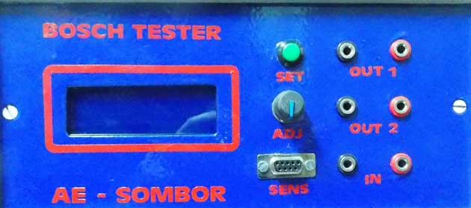

- Measure pressure 0 – 2000 bar
- Driver for control valve of common rail pump
- Test sensor pressure
- Test control valve pump
- Numeric osciloscope (numeric view pulse of control valve percent of duty circle)
- Generator pulse (for clean) 20 Hz 12v duty 0- 52%
- Generator PWM 1000 Hz duty circle 0 – 50 ms (0 – 100 % ) for control pressure
- Universal manometer (if use sensor pressure)
- Test injector (fast view global correctly common rail system)

Measure pressure in rail

Connect tester to battery 12V, . Konect sensor cable “sensor” jelow/green wire (Bosch sensor pin.2 Delphi sensor pin 1).

Numeric oscilloscope - measure PWM pulse control valve pump

Connect tester to battery 12V, “ INPWM “connector red input connect to control valve
(one of two pin) on display view “H“ high period , “L “low period, FR frequency pulse
percentage saturation PWM pulse. For use numeric scope press button set (all time in tester active is “beep” sound).
H – duration high level pulse (ms)
L – duration low level pulse
FR – frekvency pulse for control valeve pump (Hz)

Test senzors pressure

Use sensors cable. Connect cabele to sens input on tester

Bosch – black to pin 1, white pin .2 , red pin 3

Delphi – white pin 1 , black pin 2, red pin 3

test can be done in the car or on the work bench
result of pressure view on display tester

Test control valve of pump
Use PWMOUT connector of tester for connction control valve pumps, pressure sensorr
Connect to sens inuput of tester
With rotary button testers control PWM pulse 0 – 100 % and view result pressure

Generator PWM pulse (cleaning gasoline injector) 20 Hz 12v duty 0- 52%

Connect tester to battery 12V.twice push button select – entered meny strong pulse for cleaning
button “ ADJ” use for control 0- 52% pulse( Recommended 25%)
output connector “OUT 2”connect to injecor (gasoline)
press button “select” – now started cleaning
Injector must be push in liquid for cleaning

Generator PWM 1000 Hz duty circle 0 – 50 ms (0 – 100 % ) clean control valve

Cable connect to “OUT 1”, and connect to control valve. Valve must be push in liquid for cleaning
.
Powered tester with battery 12v. With “ADJ” adjust pulse 70%

manometer (with sensor)

connect tester to baterry 12V,Conect sensor to input SENS
Bosch – black to pin 1, white pin .2 , red pin 3
Delphi – white pin 1 , black pin 2, red pin 3
Senzor mount when view pressure . View pressure on display tester

Test injectors on car

Connect tester to battery 12 V. connect sensor to “SENS” input. Connect control valve of pump to “OUT1”
ADJ button to max position
Mount Tube Overflow on injectors
Start car and view overflow quantity
If car started must adjust pressure.

